CSIT314 Software Development Methodologies - Group Project

Sprint 3 - US44: Suspend IDP category
Interior Design Platform - Platform Manager
All diagrams were drawn in draw.io. Open "US44 Suspend IDP category.drawio" in this folder to edit them - each diagram is its own page in that file. The exported images are in the "diagrams" folder.

Assumptions
- The system is the Interior Design Platform from the project specification. Sprint 3 adds the Platform Manager's stories (log out and IDP categories, US40 - US45) and the Interior Designer's first IDP story (add a current IDP, US20).
- We follow B-C-E: the actor only talks to the boundary (page), the boundary only talks to the controller, and the controller works with the entity classes. There is one controller per use case.
- Only an active Platform Manager can use the IDP category pages: the account and its profile must both be Active and the profile must have the "Manage IDP categories" and "Generate reports" permissions. This is checked again from the database on every request with the US39 PlatformManagerLoginController.getAuthenticatedManager(). Someone not logged in goes to /manager/login; anyone else gets "Access unavailable" (HTTP 403).
- The manager starts from the category details page (US42). The "Suspend" button is only shown while the category is Active.
- Suspending asks "Are you sure?" first. The box is plain HTML on the details page (no JavaScript), like US6 and US11.
- "Users can no longer see or select it": a Suspended category is not in the designer's IDP category drop-down (US20), and a form posted with its id is rejected.
- Suspending keeps the category row and the IDPs already in it - nothing is deleted. The manager can still find it with the search (US45) and view it (US42).
- A category that is already Suspended, or doesn't exist, can't be suspended.

1. User story
Story ID | US44
User story | As a platform manager, I want to suspend an IDP category so that users can no longer see or select it.
Actor | Platform Manager
Priority | Medium
Story points (estimate) | 2
Acceptance criteria | 1. Given an Active category's details page, there is a "Suspend" button.  2. Given I click "Suspend", then I see an "Are you sure?" box with OK and Cancel.  3. Given I click OK, then the category becomes Suspended and I see "IDP category suspended successfully".  4. Given I click Cancel, then the box closes and nothing changes.  5. A Suspended category is no longer offered to designers when they add an IDP, and can't be selected.  6. Given the category is already Suspended, then it can't be suspended again ("This IDP category cannot be suspended").
Tasks | T44.1 Write the use case description and draw the use case diagram  T44.2 Draw the B-C-E class diagram and the sequence diagram  T44.3 Draw the wireframes for the Suspend button, the confirmation, the suspended category and the designer's drop-down  T44.4 Write the unit tests first (TDD) for IDPCategory.suspendIDPCategory(), SuspendIDPCategoryController and the page  T44.5 Code IDPCategory.isActive() and suspendIDPCategory()  T44.6 Code SuspendIDPCategoryController and SuspendIDPCategoryPage with the confirmation box  T44.7 Make sure getActiveIDPCategories() (US20) skips Suspended categories  T44.8 Run the test cases, fix bugs and push to the repo so the CI pipeline runs the unit tests

2. Use case diagram
The user story becomes one use case, UC44 Suspend IDP category. The Platform Manager is the only actor.
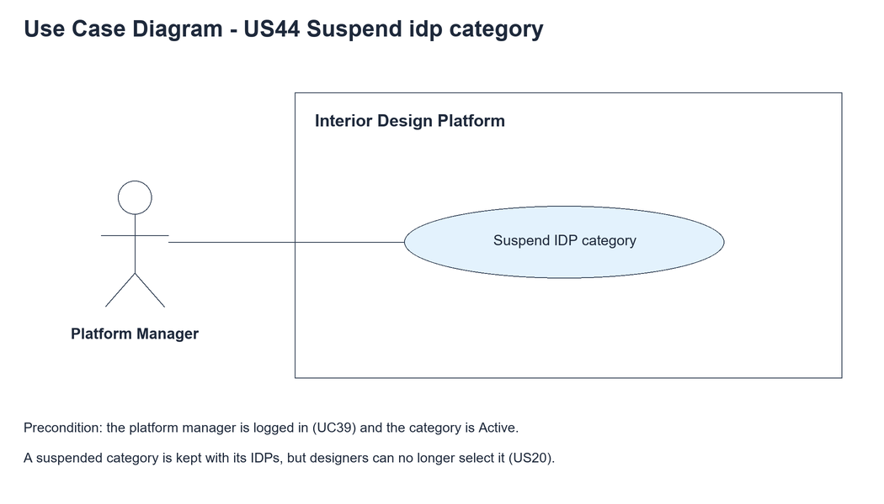
Figure 1: Use case diagram for US44 Suspend IDP category

3. Use case description
Use case | UC44 Suspend IDP category
Actor | Platform Manager
Brief description | The Platform Manager suspends an IDP category so users can no longer see or select it.
User story | US44: As a platform manager, I want to suspend an IDP category so that users can no longer see or select it.
Preconditions | The Platform Manager is logged in (UC39) and is viewing an Active category (UC42).
Trigger | The Platform Manager clicks "Suspend" on the category details page.
Basic flow | 1. The Platform Manager clicks "Suspend".  2. The system checks the manager's access and shows the "Are you sure?" box.  3. The Platform Manager clicks "OK".  4. The system checks that the category exists and is Active.  5. The system sets the category to Suspended.  6. The system shows the details page with the Suspended badge and "IDP category suspended successfully".
Alternative flows | 3a. The Platform Manager clicks "Cancel": the box closes and nothing changes.  4a. The category doesn't exist or is already Suspended: the system shows "This IDP category cannot be suspended".
Postconditions | The category is Suspended. It stays in the database with its IDPs.  Designers can no longer select it for an IDP (US20).

4. Wireframes
The wireframes were drawn in draw.io. They are low-fidelity: they show the layout and the flow, not the final colours. The orange numbers match the notes under each screen.

4a - Suspend button
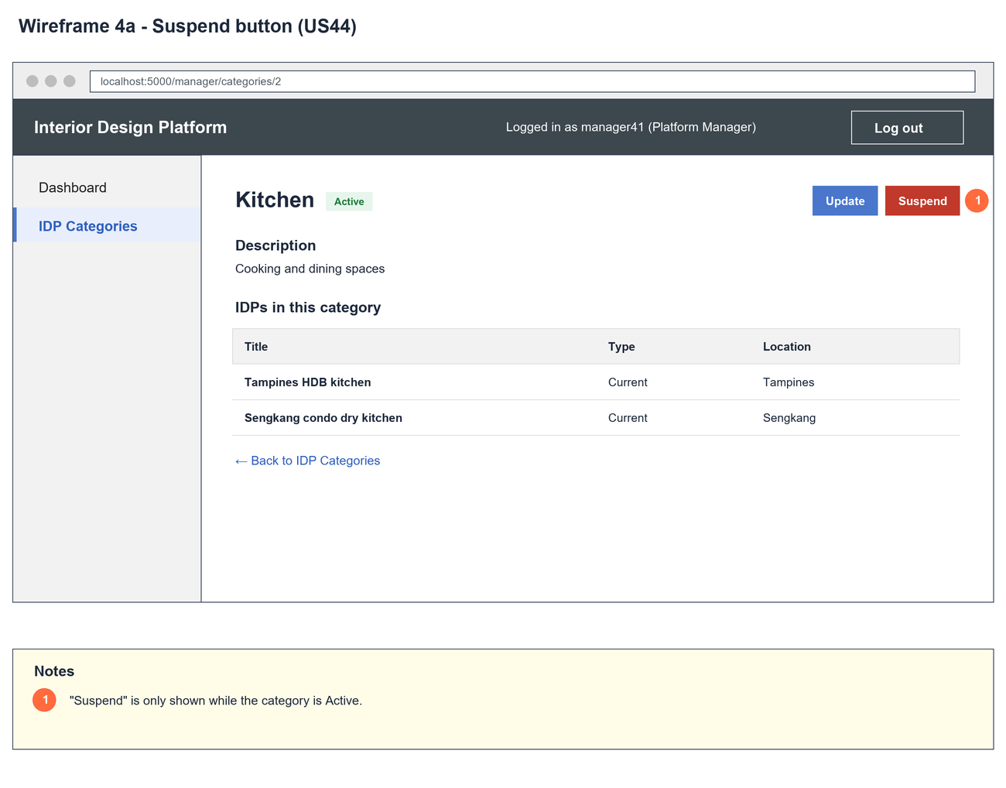
Figure 2: Wireframe 4a - Suspend button (US44)

4b - Confirm suspend
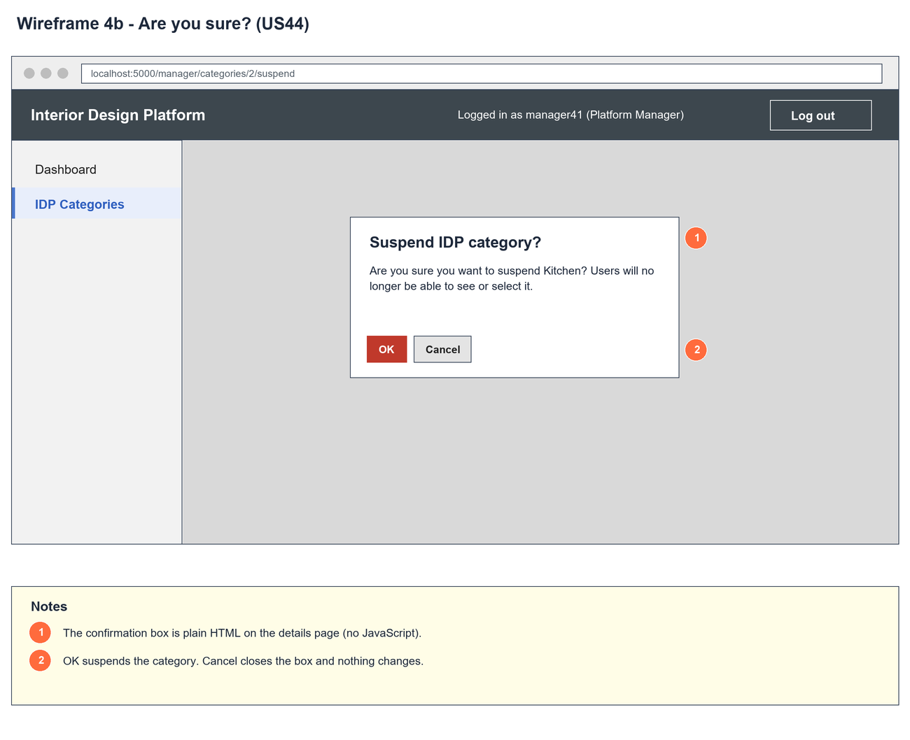
Figure 3: Wireframe 4b - Confirm suspend (US44)

4c - Category suspended
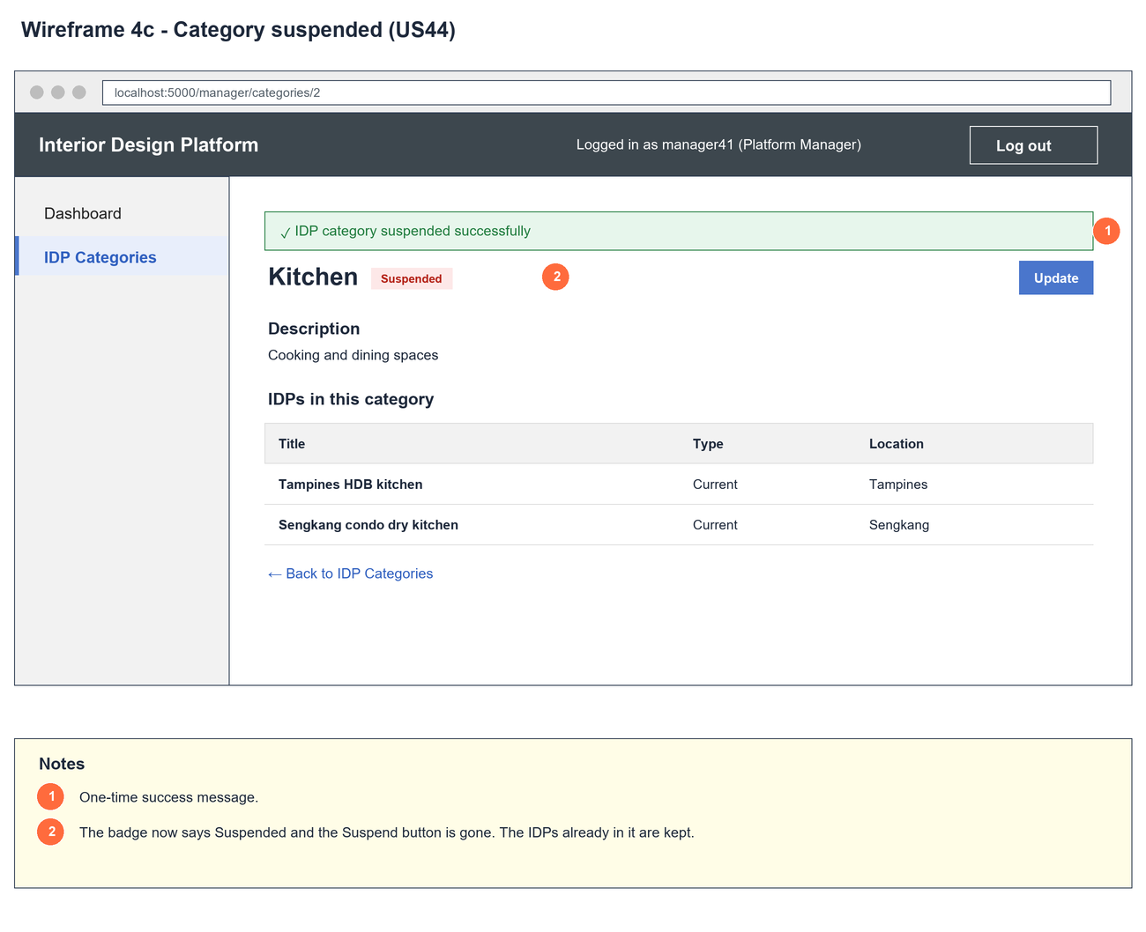
Figure 4: Wireframe 4c - Category suspended (US44)

4d - Not selectable
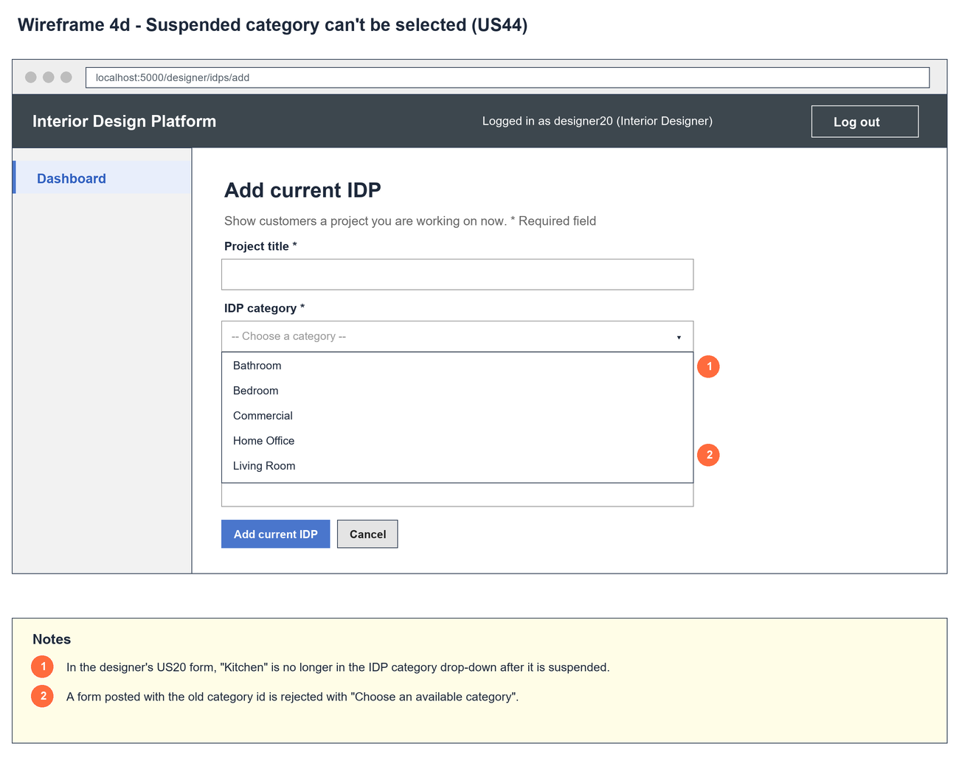
Figure 5: Wireframe 4d - Not selectable (US44)

5. B-C-E class diagram
The solid line means the boundary calls the controller. The dashed lines mean the controller uses the other classes. Only the operations needed for this use case are shown, with the same names as the code.
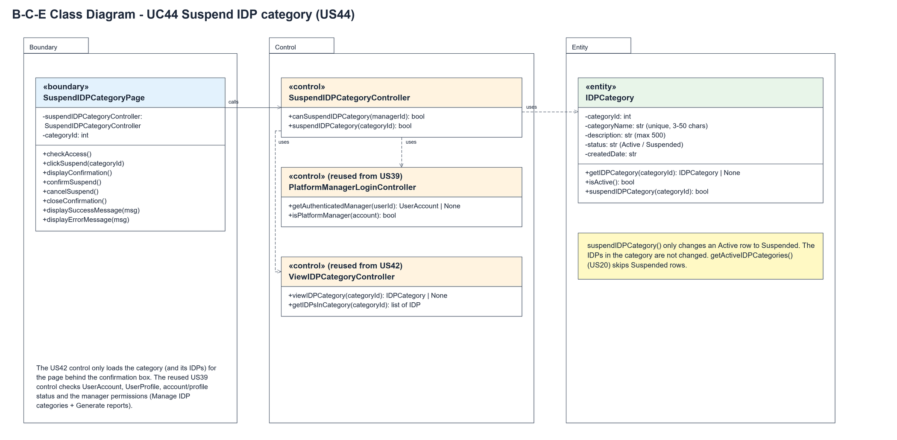
Figure 6: B-C-E class diagram for US44 Suspend IDP category
Layer | Class | What it does
Boundary | SuspendIDPCategoryPage | The Suspend button and the "Are you sure?" box. clickSuspend() shows the box, confirmSuspend() asks the controller to suspend, cancelSuspend() closes the box.
Control | SuspendIDPCategoryController | Controller for UC44. suspendIDPCategory() only suspends a category that exists and is Active.
Control | PlatformManagerLoginController (from US39) | getAuthenticatedManager() reloads the account and checks it is an active Platform Manager.
Control | ViewIDPCategoryController (from US42) | Loads the category and its IDPs for the page behind the confirmation box.
Entity | IDPCategory | isActive() checks the status; suspendIDPCategory() changes an Active row to Suspended. getActiveIDPCategories() (US20) leaves Suspended rows out.

6. Sequence diagram
The sequence diagram follows UC44. After the access check (messages 2-5) the page shows the box, using the US42 controller to load the category behind it. The outer alt is OK or Cancel. On OK the controller loads the category, checks it is Active, and the opt only suspends an Active category.
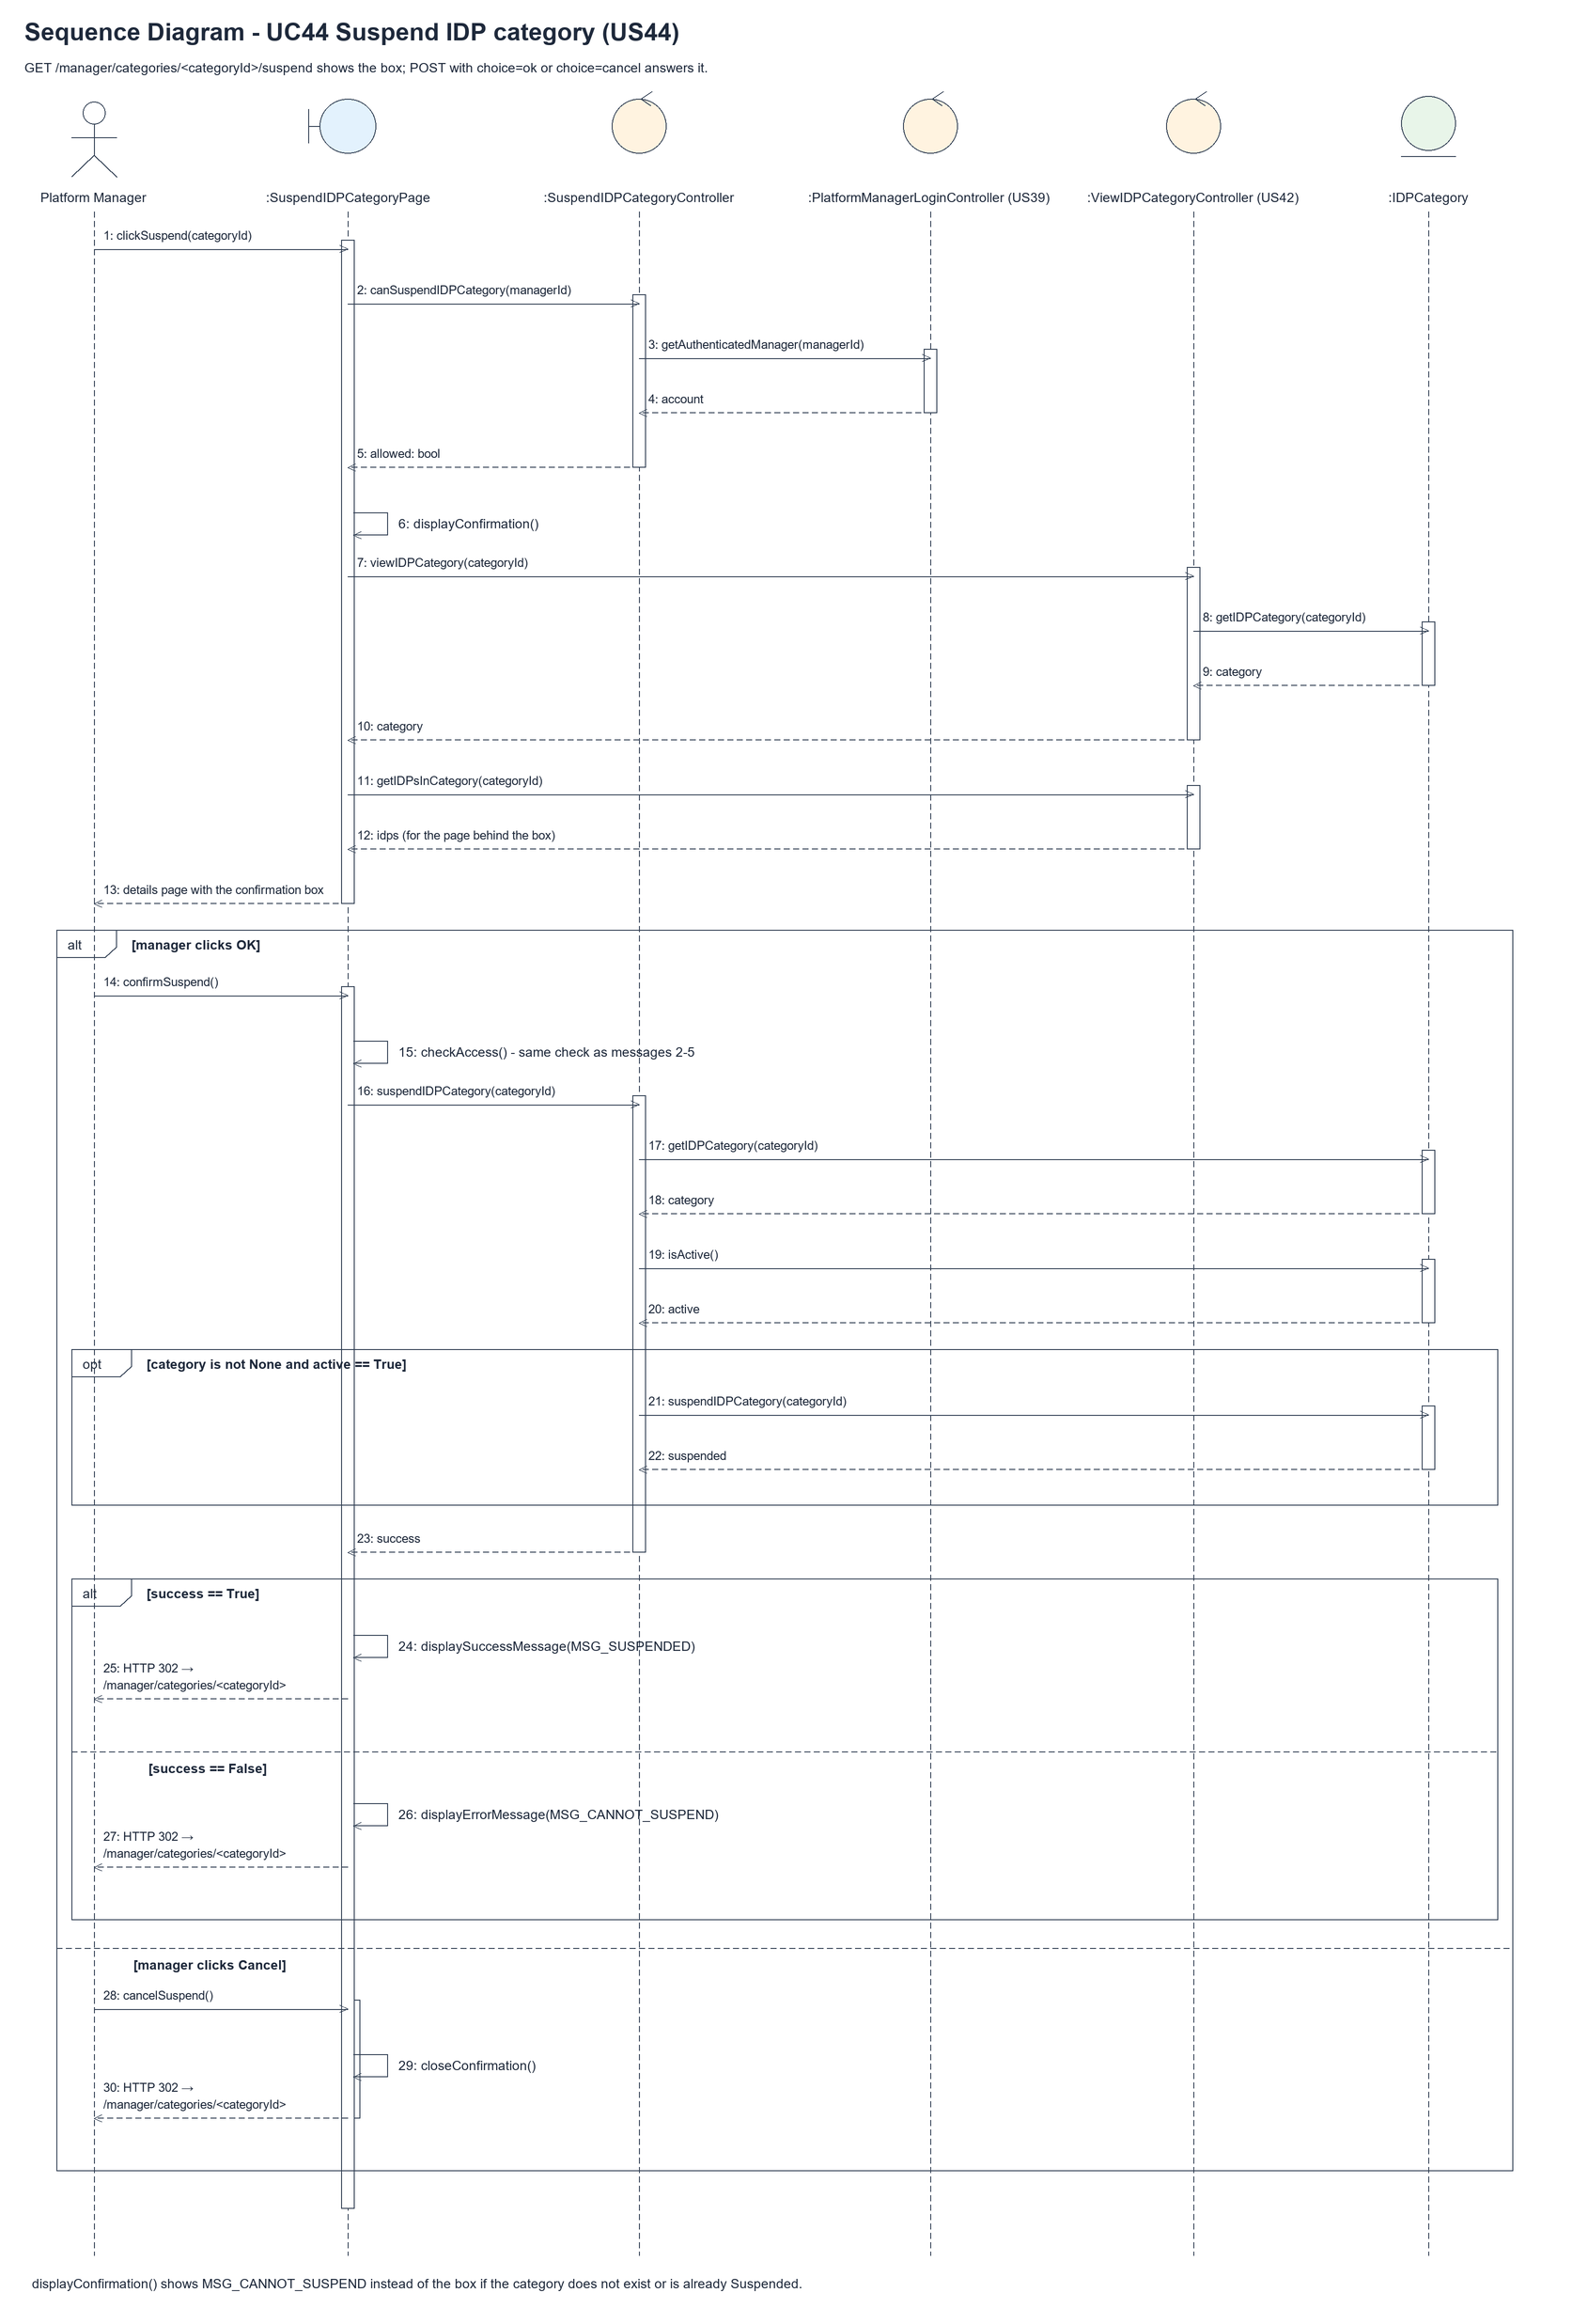
Figure 7: Sequence diagram for UC44 Suspend IDP category

7. Test cases
Test data used below (same as database/seedData.py and the test files): user profiles User Admin (id 1), Interior Designer (id 2), Customer (id 3) and Platform Manager (id 4), all Active. User accounts admin01 / Admin@123 (User Admin) and cust001 / Cust@123 (Customer). The manager account manager44 / Manager@123 (Daniel Tan, Platform Manager profile) is made first with UC8. IDP categories are made in each test with UC41, e.g. Kitchen ("Cooking and dining spaces"), Bedroom and Office. The designer account designer44 / Design@123 (Interior Designer profile) is used to check the US20 drop-down.

7a. System test cases (black box)
Equivalence partitioning and boundary value analysis were used to pick the test data. Fill in "Actual result" and "Pass/Fail" after running each test.
Test ID | Scenario | Prerequisites | Test steps | Test data | Expected result | Actual result | Pass / Fail
TC44.1 | Suspend a category | Kitchen is Active. | 1. View Kitchen  2. Click "Suspend"  3. Click "OK" | Kitchen | "IDP category suspended successfully". The badge says Suspended and the Suspend button is gone.
TC44.2 | Cancel | Kitchen is Active. | 1. Click "Suspend"  2. Click "Cancel" | - | The box closes. Kitchen is still Active.
TC44.3 | Designers can't select it | TC44.1 done. Bedroom is Active. | 1. Log in as designer44  2. Open Add current IDP | - | The drop-down has Bedroom but not Kitchen.
TC44.4 | Old form can't use it | Designer's form opened before TC44.1. | 1. Submit the old form with Kitchen | Kitchen's id | "Choose an available category". Nothing saved.
TC44.5 | IDPs are kept | Kitchen has an IDP. | 1. Suspend Kitchen  2. View Kitchen | - | The IDP is still listed.
TC44.6 | Already suspended | Kitchen is Suspended. | 1. Post OK to /manager/categories/<id>/suspend | - | "This IDP category cannot be suspended".
TC44.7 | Not a manager | Logged in as designer44. | 1. Open the suspend URL  2. Post OK | - | HTTP 403. Kitchen is still Active.

7b. Unit test cases (for TDD)
These are written before the code (test-driven development) and run with pytest. They cover normal inputs, abnormal inputs and boundary values. Each one matches a test function in tests/test_us44_suspendIDPCategory.py (UT44.n = test_ut44_n_...).
Test ID | Class and method | Input / setup | Expected output | Type | Pass / Fail
UT44.1 | SuspendIDPCategoryController.suspendIDPCategory() | Active Kitchen | True. Status Suspended | Normal | Pass
UT44.2 | SuspendIDPCategoryController.suspendIDPCategory() | Already Suspended | Returns false | Abnormal | Pass
UT44.3 | SuspendIDPCategoryController.suspendIDPCategory() | Id 9999 | Returns false | Abnormal | Pass
UT44.4 | SuspendIDPCategoryController.suspendIDPCategory() | Kitchen with one IDP | The IDP is kept | Normal | Pass
UT44.5 | IDPCategory.isActive() | Active, Suspended | True, false | Normal | Pass
UT44.6 | IDPCategory.suspendIDPCategory() | Called twice | True, then false | Boundary | Pass
UT44.7 | AddCurrentIDPController.getActiveIDPCategories() (US20) | Kitchen Suspended, Bedroom Active | Only Bedroom | Normal | Pass
UT44.8 | AddCurrentIDPController.addCurrentIDP() (US20) | Suspended Kitchen chosen | False. No IDP saved | Abnormal | Pass
UT44.9 | AddCurrentIDPPage (US20 form) | designer44 opens the form | Bedroom shown, Kitchen not shown | Normal | Pass
UT44.10 | SuspendIDPCategoryPage.clickSuspend() | GET the suspend URL | "Suspend IDP category?" box. Still Active | Normal | Pass
UT44.11 | SuspendIDPCategoryPage.confirmSuspend() | POST choice=ok | "IDP category suspended successfully". Suspended | Normal | Pass
UT44.12 | SuspendIDPCategoryPage.cancelSuspend() | POST choice=cancel | Redirect to details. Still Active | Normal | Pass
UT44.13 | SuspendIDPCategoryPage.confirmSuspend() | Already Suspended, POST choice=ok | "This IDP category cannot be suspended" | Abnormal | Pass
UT44.14 | View page after suspending | GET the details page | No Suspend button | Boundary | Pass
UT44.15 | SuspendIDPCategoryPage.checkAccess() | designer44, GET and POST | HTTP 403. Still Active | Abnormal | Pass

